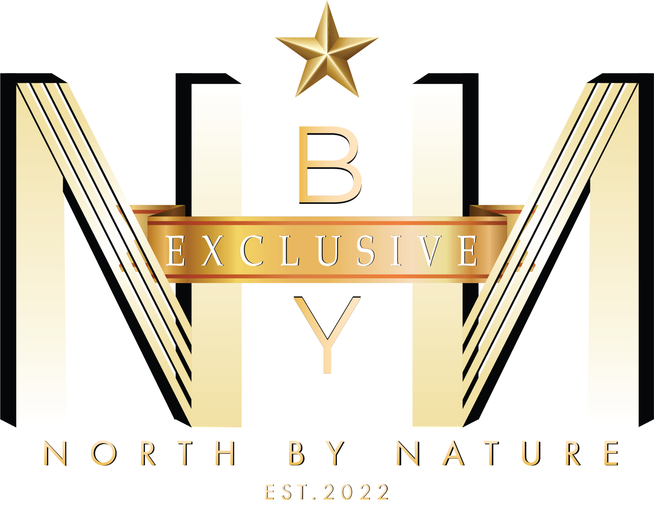

**SEATING YOU AT A TABLE YOU DESERVE TO EAT AT**

**SUMMARY OF PARTNER PERKS AND RESPONSIBILITIES**

Becoming a Partner with North by Nature Exclusive means joining an exclusive ever-growing network that connects you with unique and high-profile individuals, with a total of over 200,000 followers, including social media influencers, successful entrepreneurs, and other elite members of society. As a Partner, your business will benefit from increased exposure through our members’ social media content, including tags and posts that promote your services directly to their large and engaged audiences, and word of mouth. You'll also have the chance to collaborate with our members for exciting content creation opportunities, further boosting your brand visibility.

Our members will have their main demographic and characteristic information stored within our database, such as height, gender, ethnicity, location etc., this is so you can have a more personalised selection when requiring content creation. In addition, our members will be spread across 3 membership tiers, Basic, Gold, and Platinum. The more exclusive the tier, the more exclusive the member. However, higher tier members would require greater benefits, which may include fees. Furthermore, all members contribution to content opportunities is voluntary, it is therefore not guaranteed that specific member characteristics/membership tier groups, will be available or interested in the opportunity presented. We are also trained in social media management, and concept and content creation, for additional costs, we can support to take your social influence to a greater level.

In addition to potential advertising and content creation opportunities, your business will be considered for our exclusive private events. If you're a venue, this means you could be shortlisted as a location for our luxury events attended by high-calibre guests. Your products or services will also be promoted as part of our membership benefits programme, which gives our members exclusive discounts and perks when they visit or engage with your business. This in turn, will also generate you a higher volume of customers based on member awareness of the partnership and benefits provided.

For the first three months, the partnership is completely free, giving you a risk-free opportunity to experience the benefits of being a Partner. After that, we'll work together to agree on a partnership fee that aligns with the value you receive. Throughout the partnership, you’ll need to honour the agreed-upon discounts and ensure that benefits are only extended to valid North by Nature Exclusive members (who will show a membership card for verification).

This partnership is all about mutual growth. While you enjoy the benefits of increased exposure and customer engagement, we expect our partners to keep our members' information and our business dealings confidential. We also ask that any collaborations with our members be coordinated through us to ensure everything stays exclusive and professional.

**MEMBERSHIP AGREEMENT**

**Parties**

1. North by Nature Entertainment incorporated and registered in England and Wales with company number **[Company No.]** whose registered address is **[Address]** (hereinafter referred to as “Company”).
2. This Membership Agreement (the “Agreement”) is between North by Nature Entertainment (the “Company”) and you—the person who clicks “I Accept” (the “Member”).

**By clicking “I Accept,” you** acknowledge that you have read, understood and agree to be bound by all of the terms of this Agreement.

**1. Membership Benefits**

a. **VIP Access**: Membership grants the Member VIP access to exclusive North By Nature Exclusive events, including afterparties, brand launches, private gatherings, and other events curated by the Company.

b. **Exclusive Discounts and Offers**: The Member will receive exclusive discounts, offers, and content opportunities with The Company’s network of partners, including but not limited to bars, restaurants, and fashion brands.

c. **Personal Use Only**: Membership benefits are exclusive to the Member and are non-transferable. Any decision to extend benefits to the Member’s friends or guests is at the sole discretion of the partner.

d. **Benefit Changes**: The Company reserves the right to amend or update membership benefits as needed to enhance the member experience."

**2. Membership Responsibilities**

a. **Exclusivity with Partners**: Members are prohibited from engaging in any promotional activities, content collaborations, social media partnerships, or brand endorsements with The Company’s partners without prior written approval from the Company.

b. **Tagging and Branding**: When attending events or utilizing partner offers, the Member agrees to tag North By Nature Exclusive (@exclusivebynbn) and the respective partners in all social media content, in accordance with the Company’s branding guidelines. Failure to tag The Company or its partners consistently, as required, may result in temporary suspension of membership privileges or a formal review of membership status

c. **Confidentiality**: The Member agrees to maintain confidentiality regarding any client events they attend. This includes refraining from discussing event details if instructed to keep them private. Additionally, if requested by the client, the Member will refrain from using phones or other devices during private events. The Member agrees to maintain confidentiality regarding any information related to The Company clients, partners, events, business strategies, and operations. This includes refraining from discussing private event details or sharing any proprietary information without permission.

d. **Professional Representation**: Members are expected to refrain from any conduct that could harm the Company’s reputation, including but not limited to inappropriate behaviour at events, defamatory comments about the Company or its partners, and actions that contradict the values of the Company.

e. **Participation and Engagement**: Repeated failure to tag North By Nature Exclusive or partners, refusal of content opportunities, or lack of attendance at private events may result in a review of the Member’s status, which could lead to membership revocation.

**3. Payment Terms**

1. Memberships are currently free of charge until further notice. You will be written to update you on the status of membership cost in which you then have a period of 30 days to set up a payment plan or you may be at risk of your membership being revoked.

**4. Membership Card**

a. **Verification**: Members will be issued a membership card as proof of their status. The card is for personal use only and may not be shared or transferred to others.

b. **Replacement Policy**: Members are responsible for the cost of replacing lost or damaged cards.5. Termination and Revocation. If a membership card is lost or stolen, the Member must report it to the Company immediately. The Member is responsible for any misuse of the card prior to reporting its loss or theft and is liable for any unauthorised use of membership benefits as a result.

**5. Termination and Revocation**

a. **Right to Terminate**: The Company reserves the right to terminate membership for cause upon written notice, including violations of this Agreement, repeated non-compliance with tagging requirements, or conduct that harms the Company’s reputation. The Company also reserves the right to terminate membership without cause upon 7 days' written notice to the Member.

b. **Review Process**: The Company may review the Member’s status if they repeatedly fail to uphold tagging duties, decline content opportunities, or demonstrate a lack of engagement in private events. Such reviews may result in suspension or revocation of membership.

**6. Governing Law**

This Agreement shall be governed by and construed in accordance with the laws of England and Wales.

**7. Entire Agreement**

This Agreement constitutes the entire understanding between the Parties with respect to the subject matter herein and supersedes any prior agreements or understandings, whether written or oral.

**CONFIDENTIALITY AGREEMENT**

This Confidentiality Agreement (the “Agreement”) is made effective as of the date you click “I Agree” on our website (the “Effective Date”), by and between North by Nature Exclusive (the “Company”) and you (the “Partner”).

**1. Definition of Confidential Information**

Confidential Information refers to any information related to The Company's members, events, business operations, proprietary strategies, and partnership terms. This includes, but is not limited to:

Member identities, personal details, and membership status.

Details of private events (e.g., guest lists, locations, activities).

Internal business strategies, pricing models, vendor details, and partnership agreements.

Any media (images, videos, content) from private events or involving North by Nature Exclusive members.

Future plans, collaborations, and business arrangements.

**2. Obligations of the Partner**

The Partner agrees to:

Maintain the confidentiality of all Confidential Information and not disclose it to any third parties without prior written consent from North by Nature Exclusive.

Use the Confidential Information solely for the purposes of the partnership with North by Nature Exclusive and not for any personal or commercial gain outside of the Agreement.

Refrain from contacting or soliciting North by Nature Exclusive’s members without prior consent.

**3. Exceptions**

This Agreement does not apply to information that:

Was in the public domain at the time of disclosure.

Is required to be disclosed by law, provided that the Partner gives prompt notice to North By Nature Exclusive to seek a protective order.

**4. Duration of Confidentiality**

This Agreement and the obligations herein shall remain in effect for the duration of the partnership and for 2 years following the termination or expiration of the partnership.

**5. Breach of Confidentiality**

Any unauthorized disclosure or use of Confidential Information will be considered a breach of this Agreement and may result in immediate termination of the partnership, as well as liability for damages.

**6. Governing Law**

This Agreement shall be governed by and construed in accordance with the laws of England & Wales.

IN WITNESS WHEREOF, the parties hereto have executed this Agreement as of the day and year first above written.

**WE LOOK FORWARD TO WORKING WITH YOU**